

Hamdard University

Department of Computer Science (FEST)

***Final Year Project  
Proposal***

Services Management System for Housing Society

Abdul Moiz Hussain / BSCS-F14-0128

Muhammad Areeb Vohra / BSCS-F14-0112

Muhammad Taha Amin / BSCS-F14-0117

**Supervision from:**

Sir Adnan Ahmed Siddiqui

*(Assistant Professor)*

Table of Contents

1.0- Introduction 3

1.1- Problem Statement 3

1.2 Motivation 3

1.3 FYP Objectives 3

1.4 Literature Review 3

2.0 Project Scope 3

3.0 Methodology 4

3.1 Project Approach 4

3.2 Team Role & responsibilities (RACI matrix) 4

3.3 Requirement Development 4

3.4 Architect / Design 4

3.5 Development / Construction 5

4.0 Project Planning 5

4.1 Gantt Chart 5

4.2 Mention following *milestones* in your Plan 5

5.0 Project Requirements 6

5.1 Software tools requirements 6

5.2 Hardware requirements 6

6.0 Budget/Costing 6

6.1 Mention the budgeting cost of each item - required for the this project 6

6.2 Total Budgeted Cost - of the Project 6

7.0 Project Deliverables 6

8.0 Reference 7

# 1.0- Introduction

## 1.1- Problem Statement

In housing societies, if there is a problem regarding any household issues like electricity, plumbing, gas leakage, carpentry, fumigation or any other problems, a person himself has to go and bring a repair man, which takes a lot of time and efforts.

## 1.2 Motivation

We introduce this application which will integrate society’s every problem on a platform, and the solution will be one click away to be solved. So, that less efforts will be required from the person for their problems to be solved in a smart way.

## 1.3 FYP Objectives

* The main objective of this project is to develop a web and application based software that is used to inform about the problem of the person is having, concerning any household problems like leakage of gas, water seepage, electricity issues, plumber required for wrecked furniture etc.
* As Android based smart phones have become very popular and common devices for innovations, so we are using this platform as a user interfacing medium.
* The salient objective to develop a mobile application is for the reduction of complexity in the system and essentially to save people’s time.
* And definitely a web based service control manager where all the required services of the users will be entertained and responded.

## 1.4 Literature Review

Study of Implementation of Society Management System

The concept of this paper is that to keep the people of a society up to date with their daily activities, by notifying the activities on the application. So majority will go through with every problem or issue, along with, in the societies where people don’t interact with each other much, will be able to strengthen their neighborhood. [1]

Ubiquitous Smart Home System Using Android Application

The paper defines an android based application which uses an Arduino as a server to control the appliances of a home. This can help us in using the methodology to control not any appliances but the complaints of the society, by using internet server/domain instead of Arduino, as a connecting medium. [2]

Implementation of Society Management System: SOCIETALES

The paper focuses on the online posting of the complaints using android applications for any residential society. A society has to deal with many functions like day to day complaints, involving water supply, maintenance of electricity. So to manage and integrate everything on a single platform would help to maintain a well-defined environment within the society. This project is implemented on the housing society but we thought that it should be applied for every single apartment in the society. Every society has different criteria for the maintenance of apartments but we would make this to create a generic application once useable for almost every society management. [3]

Ubiquitous Home Control and Monitoring System Using Internet of Things

This project uses the Internet of Things (IoT) to monitor houses in the society and monitor and control appliances of the house too. It uses wireless network or 3G/4G to connect 8051 microcontroller as a hosting controller.

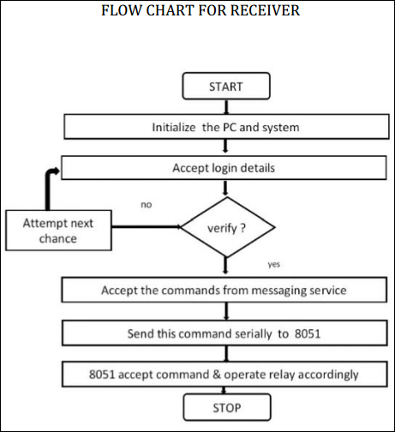

The following algorithm is used to check the online activity of the user that whether the user is connected or not.[4]

# 2.0 Project Scope

# 3.0 Methodology

## 3.1 Project Approach

Agile approach will be used.

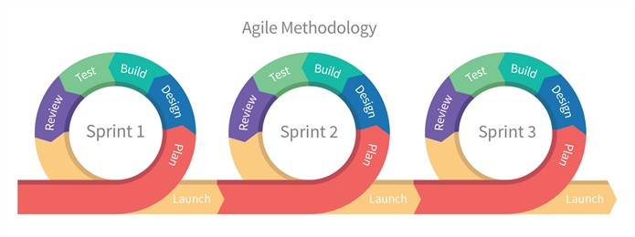

## 3.2 Team Role & responsibilities (RACI matrix)

**R**esponsibility, **A**ccountability, **C**onsultant, **I**nformed.

|  |  |  |  |
| --- | --- | --- | --- |
|  | **Taha Amin** | **Areeb Vohra** | **Abdul Moiz** |
| **Design** | R | I,C | A |
| **Analysis** | R,I | R | A,C |
| **Development** | C,I | R,A | R,C |
| **Testing** | A,I | R | A,C |

## 3.3 Requirement Development

* Elicitation of requirements
* Analysis of requirements
* Requirement Validation

## 3.4 Architect / Design

Big picture (system)

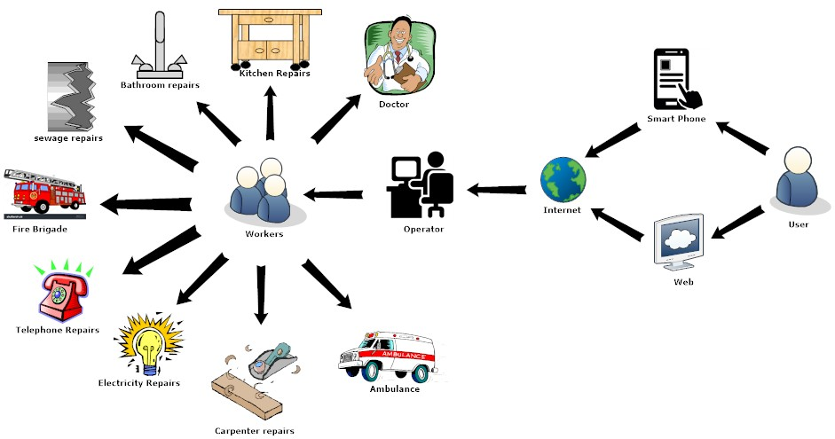

## 3.5 Development / Construction

* We will work on android studio using Java programming language for the development of smart application.
* Web based work will be developed with use of HTML, CSS, PHP and which will be connected to MySQL for back end receiver and storage of data.

# 4.0 Project Planning

4.1 Gantt Chart

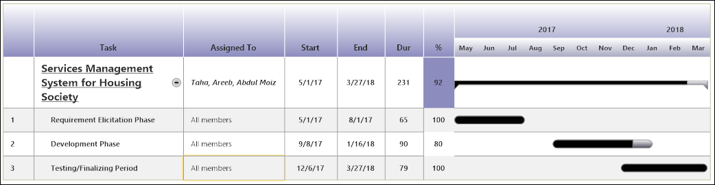

## 4.2 Mention following *milestones* in your Plan

***Progress Evaluation***  
In progress (First) evaluation of the project, we will show our near completing project.

***Final Report***  
In final (Second) evaluation of the project we will show our completed project with all the proper functionalities of applications.  
In Sha Allah.

# 5.0 Project Requirements

## 5.1 Software tools requirements

Android Studio

Word-Press

Dream-Viewer

MySQL

MS-Office

## 5.2 Hardware requirements

* Android Phone *– for application testing.*
* Desktop/Laptop Quad Core Processing Unit *– for Web interface development*
* Internet (3G/4G) Device *– for testing the connection between mediums.*

# 6.0 Budget/Costing

## 6.1 Mention the budgeting cost of each item - required for the this project

* Android Mobile [Approx. 15,000 PKR]
* Desktop Quad Core Processing Unit [~10,000-15,000 PKR]
* Internet (3G/4G) device [~4000 PKR]
* Domain [~3,000 PKR/per annum]

## 6.2 Total Budgeted Cost - of the Project

Approximate 37,000 PKR.

# 7.0 Project Deliverables

Mention the ***project deliverables*** such as

* Proposal Report
* Requirements Analysis documentation
* Design Documents (ERD, design etc )
* Running software application
* Software code in CD

# 8.0 Reference

1. Gavhane, S., et al., *Study of Implementation of Society Management System.* International Journal of Computer Applications, 2015. **132**(1): p. 34-36.

2. Kumar, S., *Ubiquitous smart home system using android application.* arXiv preprint arXiv:1402.2114, 2014.

3. Vatharkar, R., et al., *IMPLEMENTATION OF SOCIETY MANAGEMENT SYSTEM: SOCIETALES.*

4. Kumbhar, M.D.M.R.M. and A. Dilip, *UBIQUITOUS HOME CONTROL AND MONITORING SYSTEM USING INTERNET OF THINGS.* 2016.